Openshift developer sandbox

1. Open https://console.redhat.com/
2. Login with Google

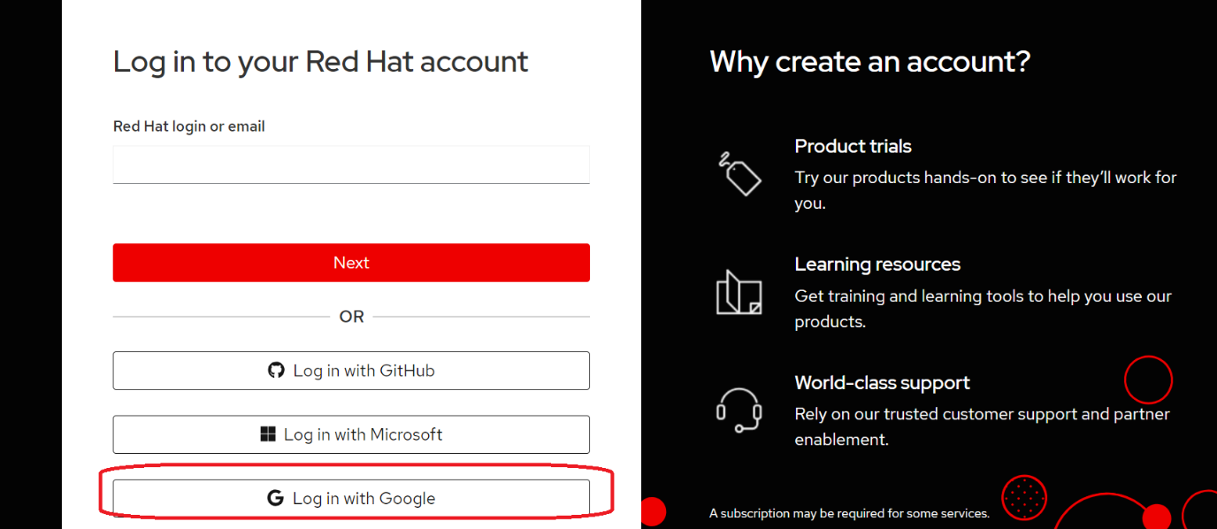

1. Click on OpenShift

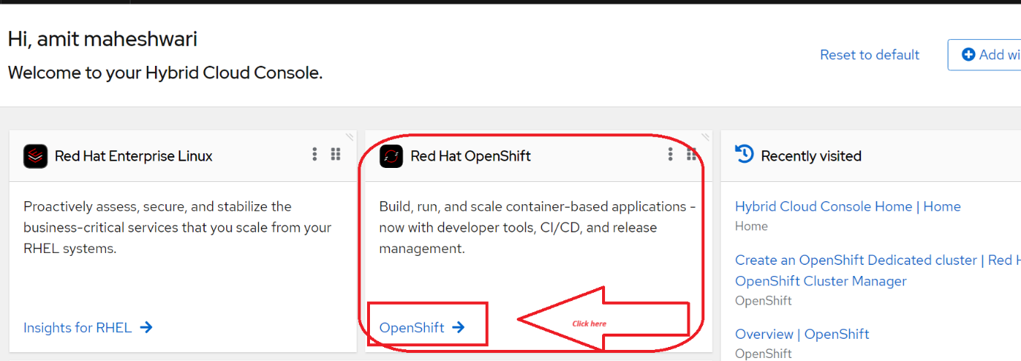

1. Click on developer sandbox

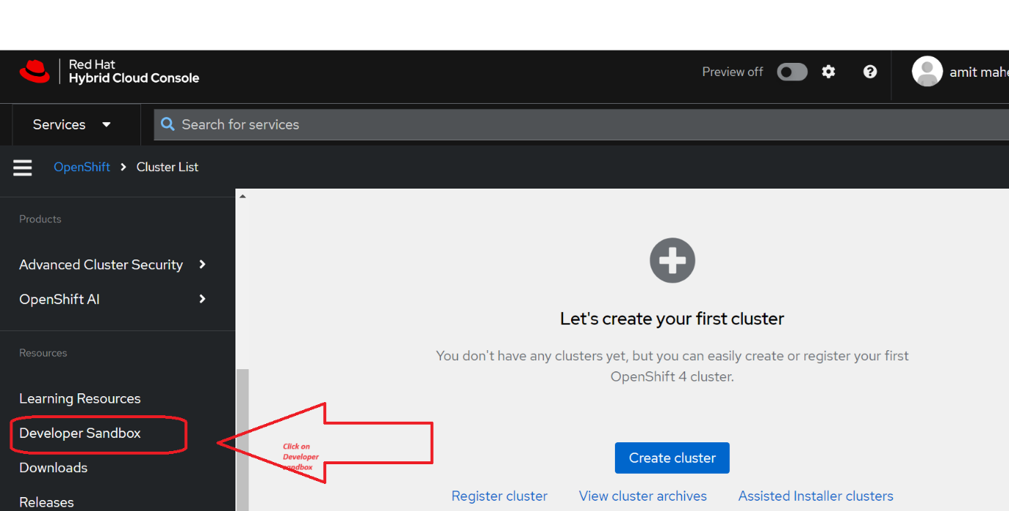

1. Click on Get started

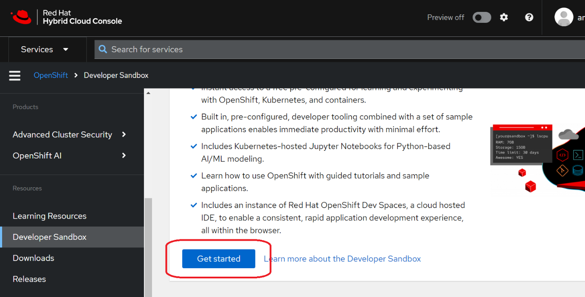

1. Launch Redhat openshift

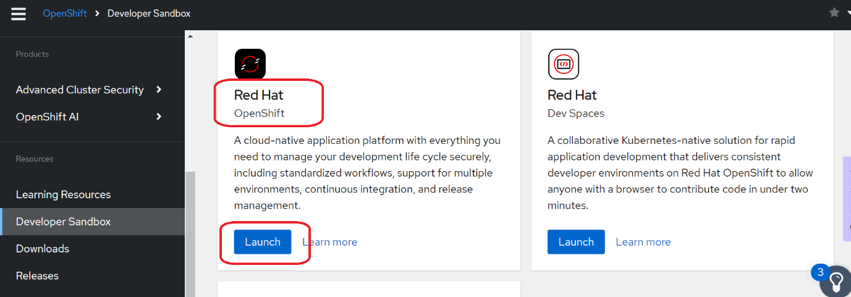

1. Login with DevSandbox

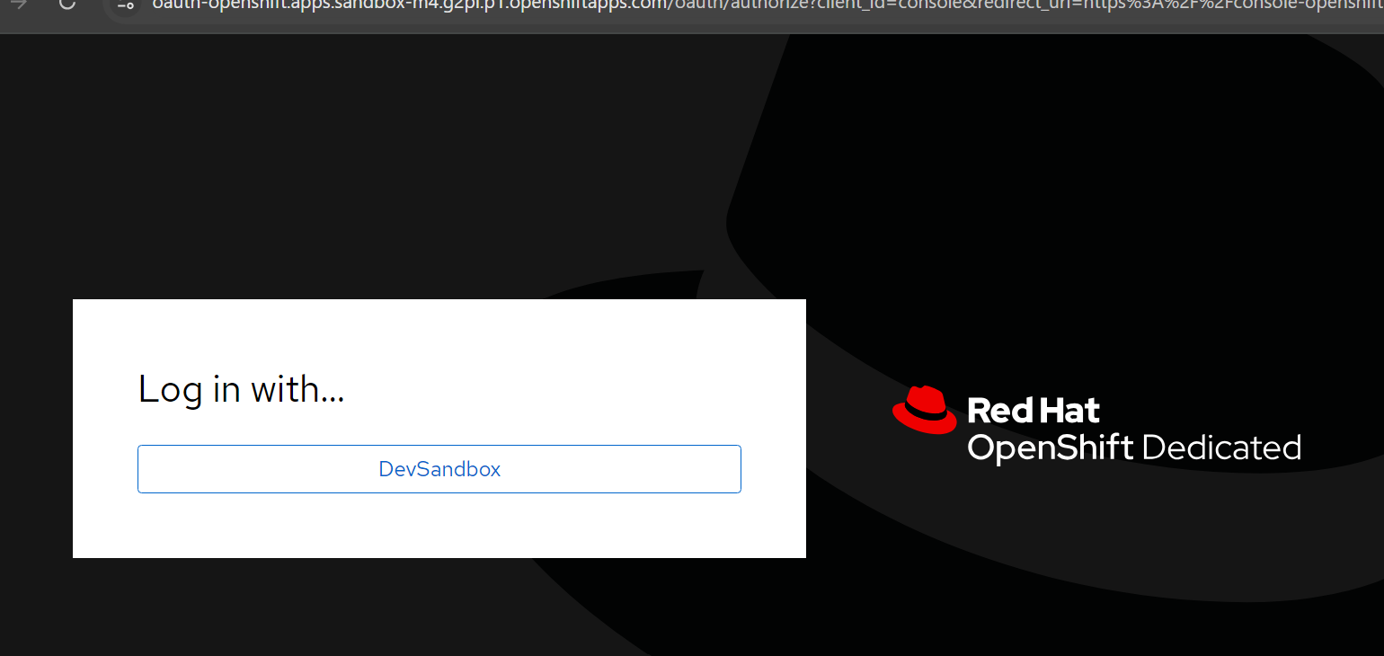

1. Again provide gmail id and password

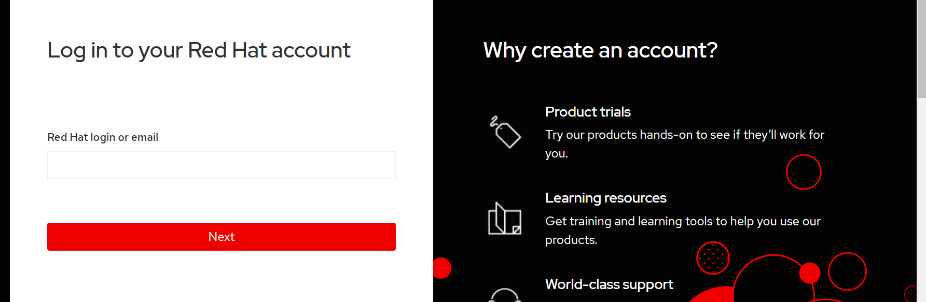

1. Skip Tour

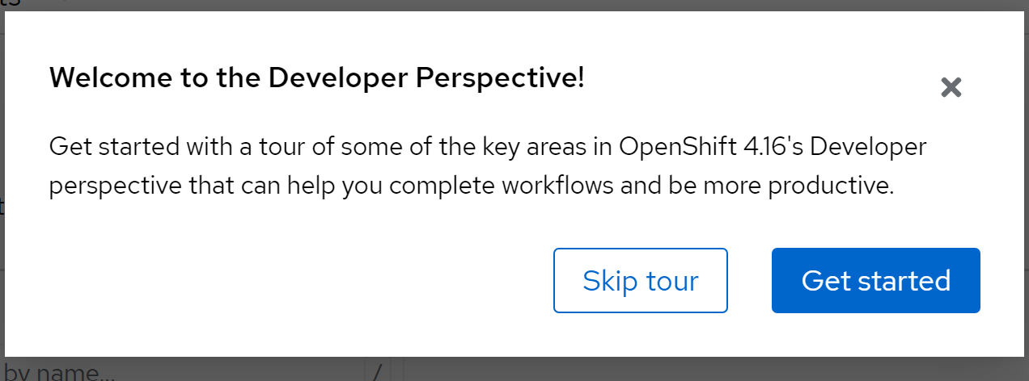

1. Select administrator

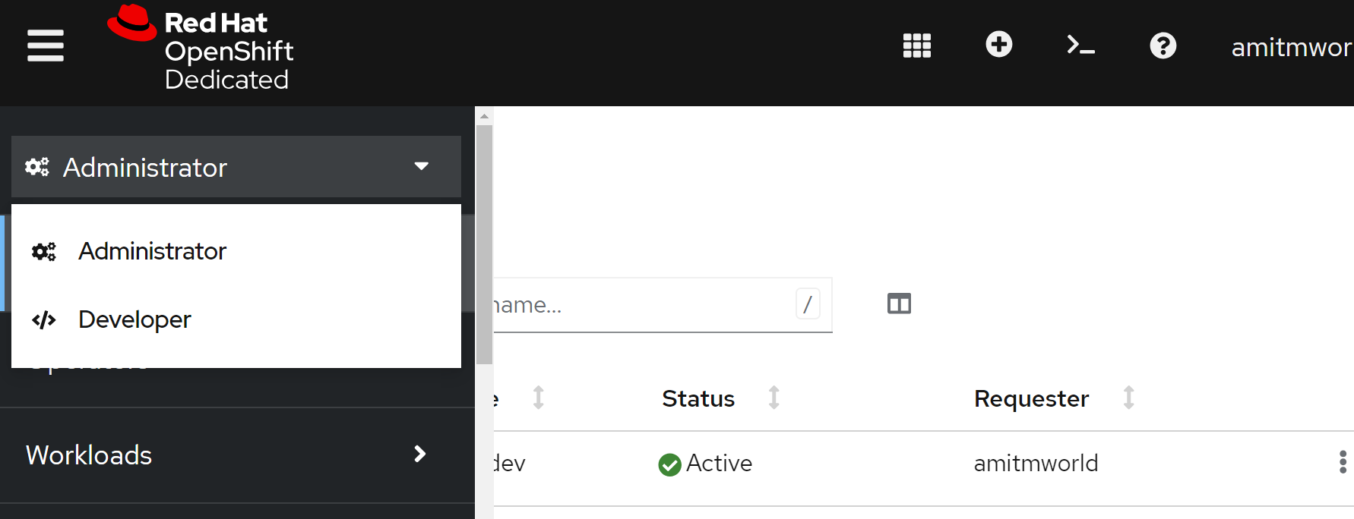

1. Click on this

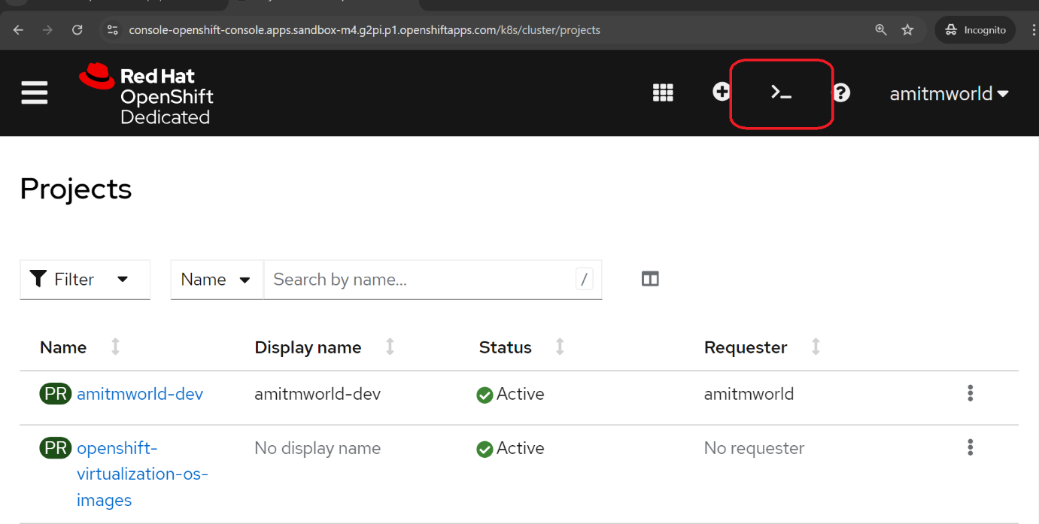

1. From the dropdown select your project

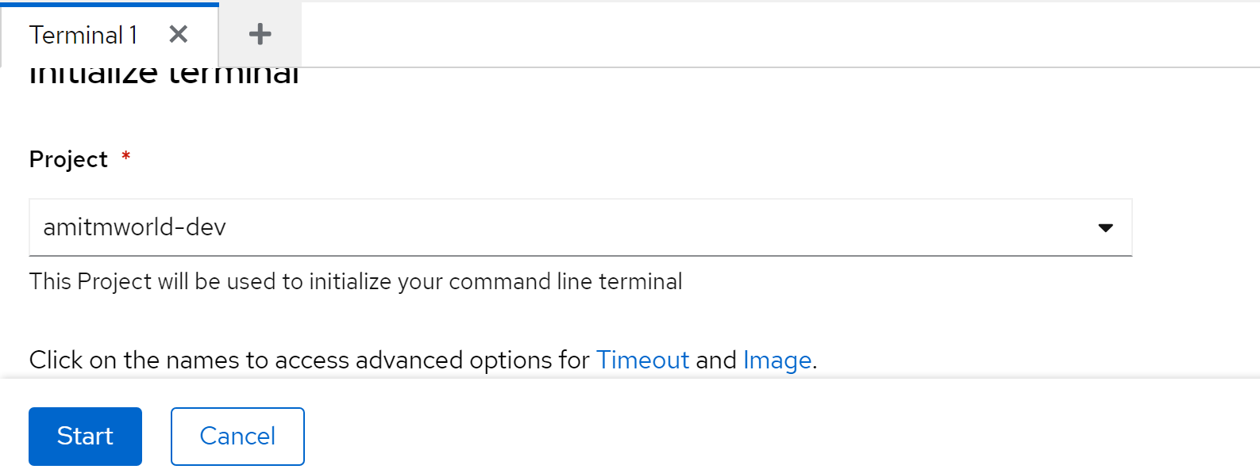

Note: In case start button doesn’t highlight, select another project , don’t click on start.

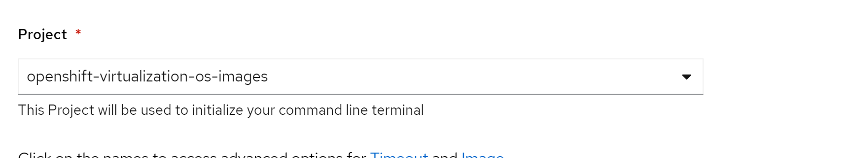

Then again from dropdown select your project and start

